Library of Congress Training for
RDA: Resource Description & Access

Using the RDA Toolkit

Revised for Toolkit releases through April 2014

For use by catalogers external to the Library of Congress

Prepared by

Tim Carlton
Cooperative and Instructional Programs Division

Library of Congress

June 2014

Library of Congress Training for
RDA: Resource Description & Access

Using the RDA Toolkit

Course Summary

This course is one element in a comprehensive suite of training developed for the Library of Congress preparation for the implementation of “RDA: Resource Description & Access” as a new set of cataloging instructions. It is intended for any person who needs to utilize the RDA Toolkit to access and apply the new rules. It is intended for staff external to LC.

In this course, participants will learn how to navigate and search in the RDA Toolkit, personalize the Toolkit, utilize user-contributed content, and locate help and additional resources.

This material has been revised to reflect the Toolkit releases through April 2014.

Learning Objectives

At the end of this course, participants will be able to:
- log into the RDA Toolkit using the ‘institutional account’ means of Toolkit access
- create and log into a User Profile
- utilize the tools on the User Menu and Document Menu
- browse the components of the Tools tab and Resources tab of the Browse Tree
- navigate in the Document pane and interpret visual cues in RDA instructions
- follow internal links to related RDA instructions and to LC-PCC Policy Statements
- navigate using the RDA Table of Contents, Glossary, and Index
- follow links from AACR2 rules to the related RDA instruction
- perform Quick Searches by RDA instruction number and topical search terms
- perform Advanced Searches to specify the documents to be searched, to exclude examples, and to limit by Instruction Type
- create and manage Bookmarks and Saved Searches
- consult pre-existing Workflows
- consult pre-existing Mappings
- locate help and additional resources

Training Methods

Guided exploration and hands-on exercises

Duration

3 hours

Table of Contents

Unit 1: Getting Started 1
What is the RDA Toolkit? 1
Ways of Accessing the Toolkit 1
Accessing the RDA Toolkit 1
Authentication and Login 2
Unauthenticated 2
Authenticated 2
User Profiles 2
Creating a User Profile 2
Rules for User Names, Profile Names, and Passwords 3
User Profile Password Email Reminder 3
Logging in for Full Access 3
Unit 2: Interface and Navigation 5
User Menu 5
RDA Quick Search 5
Go 5
Advanced Search 5
My Profile 5
Support 5
Logout 5
Browse Tree -- Tools Tab 6
RDA Mappings 6
Browse Tree -- Resources Tab 6
AACR2 6
Library of Congress-Program for Cooperative Cataloging Policy Statements 7
Other Resources 7
Tips on Using the Interface 7
Sizing the Browse Tree 7
Expanding and collapsing the Browse Tree 7
Changing the font size 7
Core elements 7
Visual cues within the instructions 7
“Page Number” icons 8
Browse Tree -- RDA Tab 8
Exercise 1. Examining the Structure of RDA 9
Chapter 0: Introduction 10
Exercise 2. Following links to LC-PCC PS 10
Exercise 3. Following links to related RDA instructions 11
Exercise 4. Using the RDA Table of Contents 11
Exercise 5. Using the RDA Glossary and Index 12
Browsing AACR2 and LC-PCC PS Directly 12
Exercise 6. Jumping from a known AACR2 rule to the related RDA instruction 12
Exercise 7. Going directly to an LC-PCC PS 12
Unit 3: Searching 13
Document Menu 13
Find URL 13
Language Select 13
Dual View 13
Previous Hit and Next Hit 13
Synch TOC 13
Return to Results 13
View Text 13
Bookmark 14
Print Text 14
Searching Basics 14
Search syntax 14
Web search engine basics 14
Sorting of search results 15
RDA Quick Search 15
Exercise 8. Searching by instruction number 15
Exercise 9. Searching by keyword 15
Exercise 10. Multiple-term searching 16
Advanced Search 16
Exercise 11. Searching by AACR2 rule number 16
Exercise 12. Specifying which documents are to be searched 17
Exercise 13. Excluding examples from the scope of a search 17
Instruction Types 18
Unit 4: Personalizing the Toolkit 21
Manage Settings … 21
Manage Personalizations … Bookmarks 22
Exercise 14. Creating bookmarks 22
Exercise 15. Navigating to bookmarks 23
Manage Personalizations … Saved Searches 24
Exercise 16. Saving a search 24
Exercise 17. Making use of saved searches 25
Unit 5: User-Contributed Content 27
Workflows 27
Maps 28
Unit 6: Help, Support, and Other Resources 29
Help with Toolkit Functionality 29
RDA Toolkit Help 29
Support 29
Toolkit Home Page 29
FAQ 30
Help Applying RDA Content 30
Examples 30
Appendix: Quick Reminders about the RDA Toolkit 31

Unit 1: Getting Started

What is the RDA Toolkit?
RDA Toolkit is an integrated, browser-based, online product that allows users to interact with a collection of cataloging-related documents and resources, including RDA: Resource Description & Access, the new set of cataloging instructions that replaces AACR2. In addition to RDA, the other resources available through the Toolkit are:
- AACR2, to help you know where to begin
- Library of Congress-Program for Cooperative Cataloging Policy Statements (LC-PCC PS)
- Workflows and other procedural documentation that is created by subscribers and can be shared within an organization or with the entire community of subscribers
- Mappings of RDA to various schemas, including MARC 21

Ways of Accessing the Toolkit
RDA Toolkit offers three options for authenticating an institutional account: IP authentication, referring URL authentication, or account ID authentication. During registration, each institution chooses one of these methods. Toolkit “Help” provides more information on each option. The user login experience varies depending on the authentication method chosen. Once you are logged in, the interface experience is uniform regardless of your authentication process.

The Library of Congress utilizes an institutional account, which is described generically on the next page. But this may not be the situation at your institution. Login procedures will need to be provided by each institution to their own staff.

Accessing the RDA Toolkit
Although the RDA Toolkit can be accessed through Cataloger’s Desktop (assuming you already subscribe to Cataloger’s Desktop), we will concentrate in this class on accessing the Toolkit directly so we learn how to utilize the ‘pure’ Toolkit.

- Open Firefox and go to the RDA Toolkit home page at: http://www.rdatoolkit.org/.

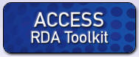The “Access RDA Toolkit” icon above the left-hand navigation pane is a link that will take the user to the Toolkit itself at http://access.rdatoolkit.org/.

- Click on the Access RDA Toolkit icon

To bypass the home page and go directly to the RDA Toolkit itself, bookmark the Toolkit URL (http://access.rdatoolkit.org). From there, you can always open the home page in a new window by clicking on the RDA Toolkit logo at the left end of the top blue banner.

Authentication and Login
The Authentication section in the right corner of the blue bar at the top of the Toolkit indicates your authentication status. The three statuses are discussed below. You should use at least the second status, “Authenticated”, and have the option of proceeding to the third status, “Full Access,” by logging into your User Profile.

Unauthenticated
An empty blue bar indicates that a user is not authenticated to an active RDA Toolkit account.
Even in this unauthenticated status, you can use some of the Toolkit functionality. You can:
- browse the Table of Contents (on the RDA tab)
- navigate the RDA Mappings (on the Tools Tab)
- view the LC-PCC Policy Statements (on the Resources tab)
- view the Other Resources (on the Resources tab)

Authenticated
However, in order to view the actual RDA instructions, you must login and be “authenticated.”

- The following steps describe the account ID method of authentication. This may not be how your institution accesses the Toolkit.

- In the first field, type your account ID
- In the second field, type your account Password
- Click on the Login icon to the right

A legend in the blue banner indicates that you are authenticated to your institutional account

In this status, you can view the RDA instructions, Shared Workflows, and the RDA Element Set View. But you do not have full use of the site until you login to your User Profile; you can then:
- manage preferences
- create and manage bookmarks
- save searches

User Profiles
The User Profile login can be easily confused with the subscription account login. The Profile Name login boxes display only after the user has been authenticated to the institution-wide account and the name of the institution appears in the blue bar (as shown above).

Creating a User Profile
In order to utilize some of the more useful Toolkit features -- User Preferences, Bookmarks, and Saving Searches -- you must login to your User Profile. This means going one step beyond the institutional login. In order to login to your User Profile, you first need to create a User Profile.

- Click on the Create Profile icon (just to the right of the Login icon)
- Complete the lower portion of the dialog box (see the example on the next page).

Full Name:
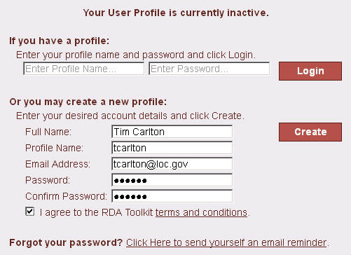Enter the name that you want to display in the banner when you have full access.

Profile Name:
Enter the Profile Name that must be entered to login to your profile.

Email Address:
Enter your email address so the system can email you a password reminder if requested by you.

Password:
Enter a Password used to login to your profile.

Confirm Password:
Enter your Password again to ensure accuracy.

- Check the “I agree to the RDA Toolkit terms and conditions” box.
- Click on Create

Rules for User Names, Profile Names, and Passwords
- No minimum or maximum number of characters
- Not case sensitive
- All ASCII characters are allowed. Non-Latin script characters are not allowed. Spaces are discouraged

User Profile Password Email Reminder
If you forget your password, you can click on the “Email Password” link (just below the institution name in the banner) once you are authenticated. After you type your email address and click on “Send,” an email with your password will be sent shortly.

Logging in for Full Access
Note: We won’t need to do this step this time, because when you first create the Profile, you are then automatically logged into that profile.
But for future logins, if you want to login to your User Profile …

- In the first field, type your Profile Name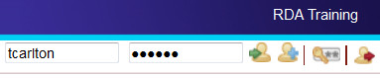
- In the second field, type your Password
- Click on the Login icon

N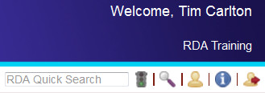ow, you will have full access and see your Name above the Institution Name

(these images illustrate a user logged into a User Profile within a special temporary training account)
Access to AACR2 via Cataloger’s Desktop
In January 2012 the Library of Congress announced that it would transition from AACR2 (Anglo-American Cataloguing Rules, second edition) to RDA (Resource Description and Access) on March 31, 2013.

AACR2 has been available via LC’s web-based cataloging documentation subscription service, Cataloger’s Desktop, as well as through RDA Toolkit. In keeping with LC’s decision to switch from AACR2 to RDA, Cataloger’s Desktop will simultaneously change how access to AACR2 is provided.

As of April 1, 2013, if you subscribe to both Cataloger’s Desktop and RDA Toolkit (which includes an online version of AACR2), you will continue to have access to AACR2. If you subscribe to Cataloger’s Desktop but not to RDA Toolkit and want online access to AACR2, you will need to establish an RDA Toolkit subscription at http://www.rdatoolkit.org/.

Unit 2: Interface and Navigation

User Menu
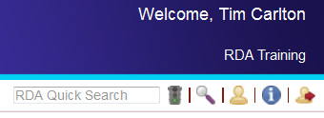The User Menu is located at the top-right of the Toolkit interface, just below the indication that you are authenticated into the institutional account. We will briefly look at each of the functions on the User Menu.

RDA Quick Search
(To be covered in hands-on detail in Unit 3)
You can search for a specific RDA Instruction number or a phrase in RDA Chapters, Appendices, Glossary, and Index. The RDA Quick Search will search only RDA itself.

Go
This icon is used to execute a Quick Search. Alternatively, you can simply press <Enter>.

Advanced Search
(To be covered in hands-on detail in Unit 3)
The Advanced Search allows you to create advanced searches of RDA and the other documents in the RDA Toolkit. It also allows you to save searches for future use.

My Profile
  - Click on the My Profile icon

“My Profile” allows you to manage your personalization of the Toolkit. You can:
- reset your current profile (Name, Email, Profile Name, and Password)
- set preferences
- run, delete, edit, and rename your saved searches
- delete or navigate to your bookmarks
- edit, share, and delete user-contributed content (Workflows and Mapping)

Support
- Click on the Support icon

“Support” is used to request support through the RDA Toolkit Support Center.

Logout
(In class, do NOT click on Logout)

Logging out takes you out of “authentication” status, and entirely closes the Toolkit.

Browse Tree -- Tools Tab
Click on the Tools tab

RDA Mappings
The RDA Mappings, created by the Joint Steering Committee for Development of RDA (JSC), help you navigate – for example, from a known MARC instruction to a related RDA instruction.

    - Click on the plus sign (+) before RDA Mappings
    - Click on MARC Bibliographic to RDA Mapping
    - Scroll down to the first entry for the 245 c subfield
    - Click on the grey link in the first column
This link opens the MARC 21 Bibliographic Format, to the 245 data, in its own window.
    - Close the new browser tab
    - Click on the blue link to instruction 2.4.2
This takes you to that instruction and changes your tab in the Browse Tree.
    - Click on the Tools tab
Similarly, you can follow the links from MARC Authority to RDA Mapping

You are encouraged to look at the other sections of the Tools Tab on your own.
RDA Mappings will be helpful as a ‘bridge’ to RDA, but should not be used as a ‘crutch’; you need to be able to confidently navigate the RDA structure.

Browse Tree -- Resources Tab
The Resources tab provides the full text of AACR2, the LC-PCC and National Library of Australia Policy Statements, and Other Resources. At first, you may find it helpful to navigate from a known AACR2 rule to the related RDA instruction, or to go directly to an LC-PCC PS.

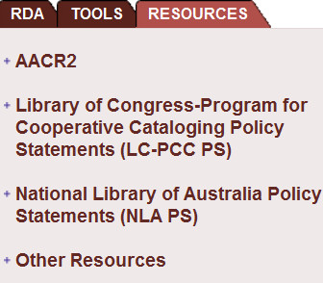 Click on the Resources tab

AACR2
- Click on the plus sign (+) in front of AACR2
- Expand the hierarchy and open the rule for recording illustrative matter for books (2.5C1)
- Click on the blue RDA link in the document pane to learn how to handle such data under RDA

Note that clicking on the link, in addition to taking you to RDA instruction 7.15.1.3, also changes your tab in the Browse Tree.

- Click on the Resources tab
- Scroll up and click on the minus sign (-) before AACR2 to collapse this view.

Library of Congress-Program for Cooperative Cataloging Policy Statements
Let’s see if there is an LC-PCC PS for the alternative to the RDA instruction we just viewed.
(Note: It is more efficient to access the LC-PCC PS by following the green LC-PCC PS link within RDA -- but the purpose of this exercise is to practice navigating the hierarchy)

- Click on the plus sign (+) in front of the LC-PCC PS
- Expand the RDA 7 hierarchy and click on the LC-PCC PS for 7.15.1.3 Alternative
- Scroll up and click on the minus sign (-) to collapse the LC-PCC PS hierarchy

Other Resources
- Click on the plus sign (+) to expand Other Resources
- Click on the plus sign (+) to expand Element Sets & Encoding Standards

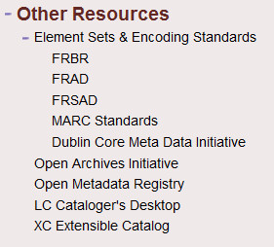We will not view these resources in class, but you are encouraged to view them on your own. Among the more useful links:
- FRBR, FRAD, and FRSAD take you to an IFLA page
- MARC Standards takes you to LC’s MARC home page
- LC Cataloger’s Desktop takes you to the login page for Cataloger’s Desktop

Tips on Using the Interface

Sizing the Browse Tree
You can increase the size of the document window by narrowing the width of the Browse Tree (sometimes referred to as the “Table of Contents,” but this is confusing because RDA itself has a Table of Contents). As in other applications, you can drag the vertical border separating the two panes; you can even hide the Browse Tree by moving the border all the way to the left.

Expanding and collapsing the Browse Tree
Expand the browse tree hierarchy by clicking on “+” signs; collapse it by clicking on “-” signs.

Changing the font size
You can increase the size of the font by pressing the key combination <Ctrl> <plus sign>.
You can decrease the size of the font by pressing the key combination <Ctrl> <minus sign>.

Core elements
The elements identified by the Joint Steering Committee as core elements are labeled with the blue legend CORE ELEMENT just below the name of the element. If there are conditions related to the core assignment, additional information will appear after the label.

Visual cues within the instructions
- Click on the RDA tab
- Click on the plus sign (+) in front of RDA
- Expand the hierarchy of Section 1: Recording Attributes of Manifestation & Item
- Expand the hierarchy as needed and display instruction 2.3.2
Definitions are indicated by reddish-brown text and a down arrow, and take you to the Glossary.
- Click on the reddish-brown text title proper in 2.3.2.1
- Click on the browser “Back” arrow to return to the previous location

References to other instructions are active links to those instructions
- Click (in the middle of the third paragraph of 2.3.2.1) on the blue link to 2.3.4
- Click on the browser “Back” arrow to return to the previous instruction.

Examples are labeled and presented on a dull yellow background.
- Scroll down to the example at 2.3.2.3

Exceptions to an instruction are presented with a label and a left margin mark, both in green.
- Scroll down to the exception at 2.3.2.5 for serials and integrating resources

Alternatives or options related to an instruction are presented with a label and a left margin mark, both in green.
- Scroll down to the optional addition within 2.3.2.6

“Page Number” icons
The larger chapters of RDA load in sections, allowing for quicker loading. For navigation, a row of ‘page numbers’ appears at the top left of the document pane. Click on the red Previous Page icon (at the left) or the green Next Page icon (at the right) to navigate among these ‘pages’ (you probably won’t know exactly which numbered page to click on to find what you need).
- Click on a few of these page numbers to quickly navigate to other parts of Chapter 2

Browse Tree -- RDA Tab
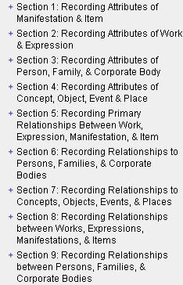The RDA tab contains the RDA instructions. The instructions are organized according to FRBR entity-relationship principles:
- Sections 1-4 concern Entity Attributes
  - Group 1 entities (Sections 1 and 2)
  - Group 2 entities (Section 3)
  - Group 3 entities (Section 4; primarily a placeholder)
- Sections 5-10 concern Relationships
    - (ignore the problematic Section 5)
    - from Group 1 entities to Group 2/3 entities (Sections 6 and 7)
    - between Group 1 entities (Section 8)
    - between Group 2 entities (Section 9)
    - between Group 3 entities (Section 10; a placeholder)

The Section numbers have nothing to do with the numbering of instructions. The first level of the instruction number refers to the Chapter. For example, RDA instruction 6.2.2.10 is in Chapter 6, not Section 6.

Exercise 1. Examining the Structure of RDA

Exercise 1a. “Where are the instructions on the identifying attributes of a manifestation?”

- Expand Section 1: Recording Attributes of Manifestation & Item
- Notice the breakdown of Section 1 into General Guidelines and then one chapter each on Identifying Manifestations and Items, Describing Carriers, and Providing Acquisition and Access Information
- Expand Chapter 2: Identifying Manifestations and Items
- Examine briefly the attributes that are covered in this chapter

Exercise 1b. “Where are the instructions on the identifying attributes of a person?”

- Expand Section 3: Recording Attributes of Person, Family, & Corporate Body
- Notice the breakdown of Section 3 into general guidelines and then one chapter on each Group 2 entity – Persons, Families, Corporate Bodies
- Expand Chapter 9: Identifying Persons
- Examine briefly the attributes that are covered in this chapter

Exercise 1c. “Where are the instructions on the relationship of a creator to a work?”

- Expand Section 6: Recording Relationships to Persons, Families, & Corporate Bodies
- Notice the breakdown of Section 6 into General Guidelines and then one chapter each on the associations of these entities with Works, with Expressions, with Manifestations, and with Items
- Expand Chapter 19: Persons, Families, and Corporate Bodies Associated with a Work
- Expand 19.2 Creator and briefly review the numerous examples of creators

Exercise 1d. “Where are the instructions on ‘related works’?”

- Expand Section 8: Recording Relationships between Works, Expressions, Manifestations, & Items
- Notice the breakdown of Section 8 into General Guidelines and then one chapter each on Related Works, Related Expressions, Related Manifestations, and Related Items
- Expand Chapter 25: Related Works
- Expand the hierarchy down to 25.1.1.3 Referencing Related Works and briefly review the numerous examples of related works

Chapter 0: Introduction
The RDA Toolkit is not meant to be read linearly, as was AACR2. As an online resource, it is designed to facilitate various means of finding the desired instructions: ‘jumping in’ via keyword searches, using the TOC to go directly to a known instruction, and following internal links to other instructions. As a result, it is not assumed that the user has read an earlier instruction providing context for subsequent instructions.

Therefore, you must first have a good understanding of Chapter 0, which addresses RDA from these perspectives:
- purpose and scope
- key features
- underlying FRBR and FRAD conceptual models
- governing objectives and principles
- structure
- core elements
- access points
- alternatives and options
- exceptions
- examples
- internationalization

We will not explore Chapter 0 in detail, but you are encouraged to review it on your own.

Exercise 2. Following links to LC-PCC PS

“Where are the instructions on recording the complicated or irregular paging of a single-volume book?”

- Expand (i.e., click on the plus sign (+) in front of) Section 1
- Expand 3: Describing Carriers
- Expand 3.4: Extent
- Expand 3.4.5: Extent of Text
- Click on 3.4.5.8 Complicated or Irregular Paging
- Scroll down to the examples and determine what is different from AACR2
What are the options permitted by RDA?
________________________________________________________

“Is there an LC-PCC PS on this instruction?”

______________

- Click on the green LC-PCC PS link
What is the LC-PCC Policy?
________________________________________________________

- Click on the blue RDA link to return to the RDA instruction

Exercise 3. Following links to related RDA instructions

“Where are the instructions on recording the ‘creator’ of a work?”

Sometimes, you need to consult instructions in several sections of RDA. For example, under AACR2, in order to provide an access point for a person as ‘main entry,’ you would consider:
- Which person deserves the main entry?
- How do I construct the heading for that person?
You would answer these questions by consulting Chapter 21 (for “choice” of access point) and Chapter 22 (for “form” of personal names)

- In RDA, you consult instructions that answer these questions:
- What is meant by ‘creator’?
- How do I record the creator?
- Do I provide an access point for the creator?
- How do I construct the ‘authorized access point’?
- How do I determine the ‘preferred name’ for the person?
- What other elements are included in the authorized access point for the person?

Let’s see how Toolkit links help you navigate chapters 19, 18, and 9 to answer these questions…
- Expand Section 6: Persons, Families & Corporate Bodies
- Expand Chapter 19: Persons, Families and Corporate Bodies Associated with a Work
- Click on 19.2 Creator
- Click on the green LC-PCC PS link and read the policy statement
- Click on the blue RDA link to return to the RDA instruction
- Scroll down to 19.2.1.3 and read the instruction on recording creators
- Click on the link to 18.4 for the general guidelines
- Follow the link to 18.4.1.2 for instruction on providing the authorized access point
- Click on the link to 9.19.1 for instruction on constructing the access point for a person
- Click on the link to 9.2.2 for instruction on choosing the preferred name of the person

Exercise 4. Using the RDA Table of Contents

“Where are the instructions on recording the title in a compilation of two or more works?”

- Click on the Table of Contents in the Browse Tree
Note that the TOC is broken down only to the first level (i.e., x.x) and cannot be expanded.
- Scroll down and click on the link to 6.2 Title of the Work
- Expand the Browse Tree hierarchy for 6.2.2 Preferred Title for the Work
- Expand the hierarchy for 6.2.2.10
- Click on 6.2.2.10.3
- Click on the link to view the LC-PCC PS on the alternative
Note that the Browse Tree jumps to the “Resources” tab.
- Click on the RDA tab

Exercise 5. Using the RDA Glossary and Index

“Where can I find a definition of “carrier type,” and instructions on recording it?”

- Expand the Glossary to the “C” portion
- Click on Carrier Type
- Expand the Index to the “C” portion
- Click on the “C” portion of the Index
- Scroll down to Carrier Type in the document pane and click on the link to 3.3

Browsing AACR2 and LC-PCC PS Directly
You may find it helpful to start with a known AACR2 rule, and then link to the RDA instruction.

Exercise 6. Jumping from a known AACR2 rule to the related RDA instruction

“What is the RDA companion to the AACR2 rule for corporate main entry?”

- Click on the Resources tab
- Expand AACR2 to 21: Choice of Access Points, expand, and click on 21.1B2
- Click on the blue RDA link, which takes you to RDA 19.2.1.1.1
- Scroll down to 19.2.1.3 and look at the examples that start with “Works of an Administrative Nature”
Does this rule look pretty familiar?

Exercise 7. Going directly to an LC-PCC PS

“I know that LC-PCC PS 1.7.5 addresses Symbols, but I can’t remember what it says.”

- Click on the Resources tab
- Display LC-PCC PS to the chapter level.
- Expand RDA 1: General Guidelines on Recording Attributes of Manifestations and Items and click on the LC-PCC PS for 1.7.5 Symbols
- Click on the blue RDA link to view examples

Update History
In accordance with agreements among national cataloging organizations, instructions and Policy Statements will change on occasion. There are 2 ways you can stay up-to-date on the changes.
- At the bottom of the RDA tab is a link to RDA Update History, arranged by date of update. The link to “Update Summary” is a brief explanation of changes. Alternatively, you can expand the hierarchy down to an instruction, and jump to the former instruction. The instructions in the Instruction Archive appear on a blue-tinted background.
- Within the RDA instructions, click on the blue icon to view the former instruction. The number in the icon refers to the year/month of the update.
To see this ‘in action’, go to 6.2.1.7.

Unit 3: Searching

Document Menu
Let’s briefly point at the icons on the Document Menu at the top right of the document pane…

Find URL
This icon allows you to quickly get a URL in order to create a link to any location in the Toolkit, which you can then copy (e.g., for pasting into an email or other document).

Language Select
This icon allows you to temporarily switch the language display to French or German, without logging into a profile and changing your preference settings.

Dual View
This icon allows you to change the single display pane to a display with two, stacked panes. With this view users can simultaneously view different language versions of RDA content.

Previous Hit and Next Hit
These icons allow you to browse forward and backward among search results to the previous and next hits within the same chapter. They are colored when active.

Synch TOC
The Browse Tree automatically ‘synchs’ as you follow links. But you can Synch TOC after scrolling. This is useful because the Toolkit has no ‘breadcrumbs’ to tell you where you are.
You can turn off this ‘automatic synching’ in “My Profile” (but why would you want to?).

Return to Results
You can click on this to return to the most recent set of search results, after you have followed a hit to its location in the document. This button is only active once you have performed a search.

View Text
The View Text menu allows you to limit the document display in several ways.
- Navigate to RDA Instruction 2.11.1.3 (note the presence of yellow-boxed examples)
- Click on View Text
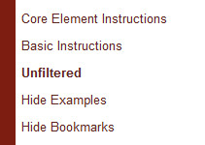The current selection appears in slightly bolder text.
- Core displays only Core instructions
- Basic displays those instructions identified by the JSC as basic to cataloging in RDA
- Unfiltered is the default, and displays the entire document.
If you select “Core” or “Basic”, ‘filtering’ labels display at the top of the Document Pane.

- Click on Core Element Instructions
The document jumps to the beginning of the ‘page’ and now displays only ‘core’ instructions.
- Click on View Text > Unfiltered
- Click on View Text > Hide Examples
- Click on 2.11.1.3 in the Browse Tree
Notice that the yellow boxes include only a mention of examples – not the examples themselves. This can be useful for reading just the instructions, uninterrupted by examples.
- Click on View Text > Show Examples

The Hide Bookmarks option hides the visual indicator that a bookmark is present. The menu toggles between “Hide Bookmarks” and “Show Bookmarks.”

You can ‘turn on’ a setting in “My Profile” to Hide Examples by default (but be sure to turn it off as necessary!). See “Unit 4: Personalizing the Toolkit.”

Bookmark
We will work with Bookmarks later.

Print Text
Clicking on this button provides only a very limited printing capability. The entire chapter opens as a “PDF” document, and you then use the PDF “Print” functions to print what you need (you will probably want to explicitly specify that you want to print only selected pages).

Consider this alternative approach:
- In the document pane, highlight the text you want to print (perhaps a single rule?)
- Click on the browser “Print” icon
- On the “Print” dialog, choose “Selection”
- Click on OK

Searching Basics

Search syntax
- To search for an exact phrase, enter it in quotation marks. For example, “Carrier Type” will retrieve the phrase Recording carrier type, but not the phrase type of carrier.
- To search for all words in any order, enter the phrase without quotation marks. For example, Carrier Type will retrieve both “Recording carrier type” and “type of carrier.”
- Use Boolean operators as needed. These include: “and”, “not”, “or”, and “w/#” (where # is a number indicating the desired proximity between the two words). Using multiple words in a search without any Boolean operators is processed as an “and” search; e.g., copyright date and copyright and date will retrieve the same results.
- Use the asterisk (*) to indicate truncation. For example, abbreviat* will retrieve “abbreviate,” “abbreviated,” “abbreviation”, and “abbreviations.”

Web search engine basics
- Searching is not case-sensitive.
- Punctuation is not important; entities. and entities will retrieve the same results.
- Spacing is important; access point and accesspoint will not retrieve the same results.

Sorting of search results
Search results are sorted by relevance, based on the number of occurrences within a document and the relative position of each hit within the document (i.e., is it in a heading or paragraph?).

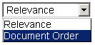After any search which yields more than one result, you can re-sort the results by instruction number. Simply choose “Document Order” from the menu at the top-right of the results (this setting does not carry forward to your next search).

RDA Quick Search
The quickest, most direct searches are by RDA Instruction Number or by keyword(s).

Exercise 8. Searching by instruction number

- Click in the RDA Quick Search box
- Type 6.2.2.10
- Press <Enter>
You are placed at the rule, “Recording the Preferred Title for a Compilation of Works […]”
- View the RDA Browse Tree to see the hierarchical context for this instruction

The punctuation for this search is very literal. You must include the periods which distinguish sub-sections of instructions. Do not use other punctuation such as slashes, commas, or spaces; you will retrieve very different -- and perhaps many more -- results.

Tips:
- You can quickly get to the beginning of a chapter by searching for the “.0” instruction of that chapter (e.g., “6.0”).
- If you enclose an instruction number in quotation marks (e.g., “6.2.2.10”), you will retrieve a results list which includes a) that instruction and all of its sub-instructions (e.g., 6.2.2.10.1, etc.) and b) any instructions which include a link-reference to that instruction.

Exercise 9. Searching by keyword

- Click in the RDA Quick Search box
- Type frequency
- Press <Enter>
- Click on the hit 2.14, which appears to be the base instruction
- Click on Return to Results to determine if you need to consult any other instructions
Note that there are 17 results, several of them in the Glossary or Index (listed at the bottom).
- Click on the first result
- Click on the Next Hit icon a few times to see that this does advance through hits in rule-number order, and also that there are more than 17 hits, because the term appears several times in certain ‘results’.
- View the RDA Browse Tree to see the context for the current instruction

‘Hits’ and ‘results’ are not the same thing.

Exercise 10. Multiple-term searching

“How does the use of multiple terms affect my search?”

- Click in the RDA Quick Search box
- Type compilation
- Press <Enter>
You retrieve results for “compilation of works” (which we do want), but also compilation of musical excerpts, laws, treaties, etc. How many results do you get? _______
- Click in the RDA Quick Search box
- Type compilation works
- Press <Enter>
You now retrieve fewer results, and they are more on target. How many do you get? ______
But we want to find the instruction for a compilation of non-musical works in one form
- Click in the RDA Quick Search box
- Type compilation works form
- Press <Enter>
- Click on the first result

Advanced Search
The Advanced Search allows you to refine your search in several ways. You can:
- use the AACR2 rule number as your search strategy in searching RDA
- specify which documents are to be searched -- or which sections of those documents
- broaden a search by choosing additional documents to be searched, beyond RDA itself
- exclude examples from the scope of a search
- narrow a search by choosing from among the different “instruction types”
- save a search
- take advantage of the Toolkit’s ability to ‘remember’ your previous search

Exercise 11. Searching by AACR2 rule number
You may find it useful to search RDA for a known AACR2 rule number, and let ‘behind the scenes’ coding lead you to the related instruction(s) in RDA.

For example, to find the RDA instruction on changes in title proper for a serial :
- Click on the Advanced Search icon
Note that RDA is already selected in the “Select Document(s) to Search” box
- Click on the Clear Previous Search icon
- Type 12.1b8 in the “AACR2 Rule Number” box
- Press the <Enter> key
The Results List shows that this AACR2 rule has two relevant ‘companion’ rules in RDA
- Click on the result for Serials

Note: Because the mapping of AACR2 rules to RDA instructions works ‘behind the scenes’, you can be more likely to retrieve all relevant mappings if you truncate your search string and add the wildcard symbol (i.e., search for “21.1b*” rather than “21.1b2”).

Exercise 12. Specifying which documents are to be searched

“How can I find the instructions on how to record a person as creator?”

- Click on the Advanced Search icon (not the header above the search results)
- Click on Clear Previous Search
- Type person creator in the search box
- Click on Search
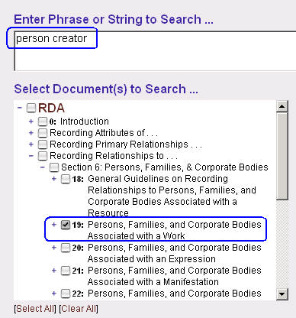The Results are from various parts of RDA -- Chapter 19 (how to record), Chapter 18 (core elements), Chapter 6 (attributes), the Appendices (relationship designators), and in the Introduction. I just want to see the instructions on recording the relationship of a person to a work.
- Click on the Advanced Search icon
The default is to search all of RDA.
- Uncheck the box in front of RDA
- Expand the hierarchy and check only the box in front of Chapter 19 (it’s in Section 6)
- Click on Search

“How can I find guidance on when to provide a formal contents note for a compilation?”
- Click on the Advanced Search icon
- Click on Clear Previous Search
- Type contents notes in the search box
- Check the boxes to search in RDA and LC-PCC PS
- Click on Search
The first hit is probably the most useful hit; if you had searched this only in RDA, this hit would not be retrieved, nor would any hit that link you to this hit.

Exercise 13. Excluding examples from the scope of a search

“How can I find a term only in an instruction? I don’t want to see dozens of examples.”

- Click on the Advanced Search icon
- Click on Clear Previous Search
- Type creator in the search box
- Check the boxes to search in RDA and LC-PCC PS
- Click on Search
- Click on the first result and then advance using “Next Hit”
There are many more “Hits” than “Results,” because every example in 19.2 includes the phrase “Authorized access point representing the creator.” Let’s make this a more manageable search:
- Click on the Advanced Search icon
- Click on Exclude Examples
- Click on Search
- Click on the first result and then advance using “Next Hit”

There are seemingly only a few less “Results,” but now you won’t stop on every example.

Instruction Types

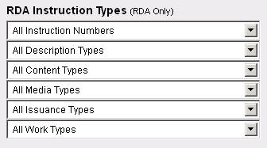To further narrow your search, you can specify the type of instructions to be searched, by selecting from the drop-down menus on the “Advanced Search” dialog. These menus take advantage of behind-the-scenes coding which tags instructions as belonging to one or more of the “instruction types.”

Note: You can select from more than one of these filter menus for a single search.

We will not explore this function in detail; at the end of this Unit are two suggested exercises for you to try on your own.

All Instruction Numbers
Accept this default, or limit the search to:
- Core

All Description Types
Accept this default, or limit the search to:
- 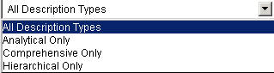Analytical
- Comprehensive
- Hierarchical

All Content Types
Accept this default, or limit the search to:
- 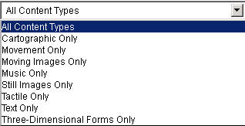Cartographic
- Movement
- Moving image
- Music
- Still images (visual or tactile)
- Tactile (movement, music, still image, text, or three-dimensional form)
- Text (notated, spoken, or tactile)
- Three-dimensional forms (visual or tactile)

All Media Types
Accept this default, or limit the search to:
- 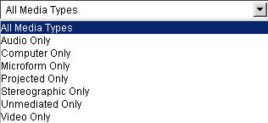Audio
- Computer
- Microform
- Projected
- Stereographic
- Unmediated (content designed to be perceived directly through the human senses without an intermediating device)
- Video

All Issuance Types
Accept this default, or limit the search to:
- 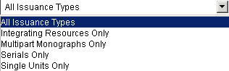Integrating resources
- Multipart monographs
- Serials
- Single units

All Work Types
Accept this default, or limit the search to:
- Legal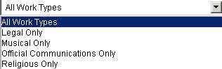
- Musical
- Official communications
- Religious

Suggested exercises to do on your own

- Click on the Advanced Search icon
- Click on Clear Previous Search
- Type preferred title in the search box
- Click on Search
There are too many results, and I only want those related to videorecordings. I could do this…
- Click on the Advanced Search icon
- Search for preferred title videorecordings in the search box
- Click on Search
There are many fewer results -- and not really what I want to consult.
- Click on the Advanced Search icon
- Remove videorecordings and search for only preferred title in the search box
- Select Moving Images Only from the “All Content Types” menu
- Click on Search
I can quickly see the relevant result -- a chapter 6 instruction on constructing the authorized access point for a collaborative work (a motion picture is considered a collaborative work).
- Click on the result for 6.27.1.3
- Click on the Next Hit arrow until you see the instruction that applies specifically to “moving image works.”
Q. Why was this result -- the one that really helps us -- not retrieved by the previous search?
A. The term “videorecording” does not appear with the term “preferred title” in 6.27.1.3, as we requested by doing an implied “AND” search. We searched too narrowly.
Q. But if the term “videorecording” does not appear with the term “preferred title” in 6.27.1.3, why was this instruction retrieved by the second search?
A. We did not include the term “videorecording” in our search syntax. By specifying the Content Type, we specified only that we wanted to find the term “preferred title” in an instruction that relates to moving images. Note that that exact term does not appear in the instruction (there is a paragraph captioned “Moving image works” that uses the term “videos,” but that is not an exact match for the search term); the programmers used their human intelligence to code this instruction as relating to “Moving Images”.
Q. Why are there hits in 6.27.1.3 not specific to videorecordings?
A. Because the entire instruction has been identified as relevant to motion pictures, the search will highlight all “hits” of the term “preferred title” in this “result.”

Let’s try another one …

- Click on Advanced Search
- Click on Clear Previous Search
- Type sources in the search box
- Click on Search
Yikes! Way too many hits! I only want those related to computer resources. I could include the term “computer” to narrow the search…
- Click on Advanced Search
- Search for sources computer in the search box
- Click on Search
There are only a few results -- but they do not include the instructions in 3.19, which relate to the sources for carriers and digital file characteristics.
- Click on Advanced Search
- Remove computer and search for only sources in the search box
- Select Computer Only from the “All Media Types” menu
- Click on Search
The results now include instructions on the sources for such elements as resolution, transmission speed, file size, encoding format, file type, etc.
- Click on any of the 3.19 results and advance using “Next Hit”
Do you see the word “Computer”?

Why did these searches work differently?

Unit 4: Personalizing the Toolkit

Manage Settings …
- Click on the My Profile icon (in the User Menu)

- We will first look at the settings in the lower portion of this screen.

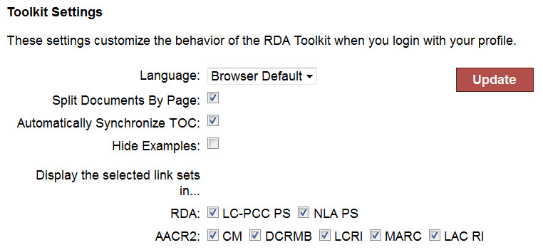Remember:
you only see these preferences if you are logged into your user profile.

Language
LC staff should continue to use “Browser Default.” The French and German translations are not in ‘synch’ with the current English version of RDA.

Split Documents By Page
This setting allows the Toolkit to load large chapters in sections, which you navigate using the “Page Number Icons”. See the discussion of “Page Number Icons” on p. 8.

Automatically Synchronize TOC
This setting allows the Toolkit to automatically ‘synch’ the Browse Tree as you follow links. See the discussion of “Synch TOC” on p. 13.

Hide Examples
With this setting checked, the Toolkit automatically ‘hides’ the yellow-box examples in the Document Pane. See the discussion of the “View Text” menu on p. 13.

Display the selected link sets in …
Subscribers to Cataloger’s Desktop are able to access AACR2 from Cataloger’s Desktop provided they have a current subscription to RDA Toolkit. Subscribers to both Toolkit and Desktop benefit from bidirectional links between Cataloger’s Desktop and the RDA Toolkit.

The Toolkit has enhanced the display with ‘turn-on-able’ links to the following resources:
- Cartographic Materials
- Descriptive Cataloging of Rare Materials (Books)
- Library of Congress Rule Interpretations
- MARC 21
- Library and Archives Canada Rule Interpretations

- The upper portion of the “My Profile” dialog is used to “Manage Personalizations,” such as Bookmarks and Saved Searches. Since we have not yet created any of these, nothing appears here.

- We don’t need to do anything special to get out of this “My Profile” dialog; we just need to do something else – which we will do in our next step.

Manage Personalizations … Bookmarks
You may find yourself repeatedly consulting the same instructions, and want to go to them more quickly in the future -- just as bookmarks help you do in other material. You can create Bookmarks in the Toolkit, and then navigate quickly to them, rather than browsing or searching.

Exercise 14. Creating bookmarks

- Click in the RDA Quick Search box
- Type 19.2
- Press <Enter>
- Click on Bookmark in the Document Menu
- Click on Add in the “Manage Bookmarks” dialog
- Click in front of the instruction number 19.2.1
- Click in the “Bookmark Name” field and type Creator
- (If you wish) Type a Bookmark Annotation
- Click on Set
You should now see a graphic indicating that you have set a bookmark here.
Note that it doesn’t necessarily appear exactly where you clicked.

Let’s set a bookmark for the Appendix guidelines on Relationship Designators for Creators.
- Click on the Advanced Search icon
- Click on Clear Previous Search
- Type creator in the search box
- Un-check RDA as a document to search
- Expand the hierarchy for RDA and check Appendices
- Click on Search
- Click on the first result
- Click on Bookmark in the Document Menu
- Click on Add in the “Manage Bookmarks” dialog
- Click in front of architect
- Click in the “Bookmark Name” field and type Creator rel des
- Click on Set
Let’s do one more. Let’s say you often have to find the LC-PCC PS on which name to choose for a corporate body if the name appears in different languages. You know that this instruction relates to an “attribute” and is discussed somewhere in Chapter 11.

- Click on the Advanced Search icon
- Click on Clear Previous Search
- Type form name language in the search box
- Un-check RDA as a document to search
- Expand the RDA hierarchy and check Chapter 11 (in Section 3)
- Click on Search
- Click on the result for 11.2.2.5.2
- Click on the link to the LC-PCC PS
- Click on Bookmark in the Document Menu
- Click on Add in the “Manage Bookmarks” dialog
- Click in front of LC practice/PCC practice for Alternative
- Click in the Bookmark Name field and type Corp body mult lang LCPCCPS
- Click on Set
- Click on the link to return to the RDA instruction

Exercise 15. Navigating to bookmarks

- Click on Bookmark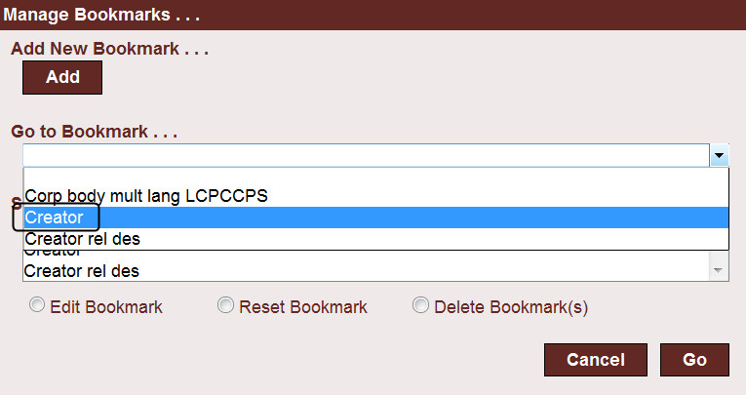
- Click on the Go to Bookmark … drop-down menu
- Select Creator
- Click on Go

Let’s do another …
- Click on Bookmark
- Click on the Go to Bookmark … drop-down menu
- Select Corp body mult lang LCPCCPS
- Click on Go
These steps take you directly to the Bookmark -- even if the bookmark is in the LC-PCC PS.
- Click on Bookmark
- Click on the Go to Bookmark … drop-down menu
- Select Creator rel des
- Click on Go

From this dialog you can also Edit, Reset, or Delete a bookmark
- ‘Edit’ allows you to rename a bookmark, add a link, add or edit an annotation, or change the sharing mode
- ‘Reset’ is supposed to allow you to move a bookmark; but this seems problematic

You can also access your existing Bookmarks from the “My Profile” screen, either to go to them or to edit them.

Manage Personalizations … Saved Searches
This feature can be useful in ways similar to ‘Bookmark’ situations -- you’ve searched your way to instructions you’ll need to consult again, and you don’t want to re-create the search syntax.

You might find “Bookmarks” to be more useful for jumping quickly to frequently-consulted instructions, and “Saved Searches” to be more useful when you’ve done a complicated search, or finally found the correct instruction after trying several strategies.

Consider this scenario:
Sometimes it is difficult to determine when an instruction concerns how to record an element and when it concerns how to construct an access point. A bookmark would always take you to the same instruction. But you could save a more broad search that yields a broader set of results.

Exercise 16. Saving a search

- Click on the Advanced Search icon
- Click on Clear Previous Search
- Type “period of activity” in the search box (include the “ ” to search it as a phrase)
- Make sure that RDA has been checked as a document to search
- Click on Search
The search yields results found in several parts of Chapter 9 -- general guidelines, specific instructions on constructing an access point, etc. -- and a few in other areas of the instructions, including the Appendices. Let’s try to narrow this down a bit.
- Click on Advanced Search
- Type “period of activity” “access point” in the search box (include both sets of “ ”)
- Click on Search
The search yields fewer results.

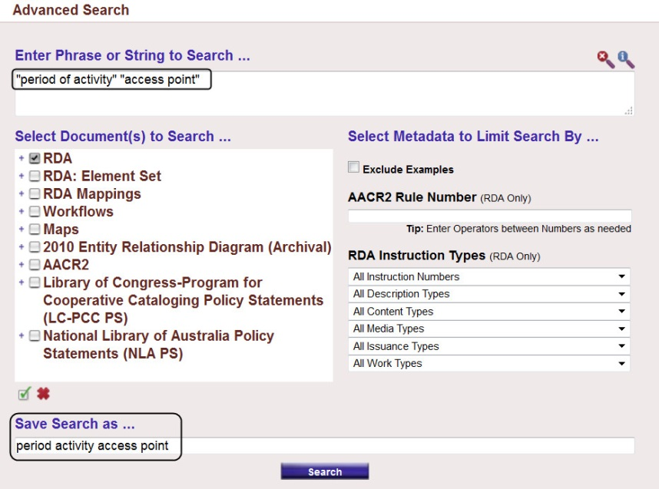You don't want to recreate this search every time, and you don't want to create a bookmark for 9.19.1.5 because you may want to also see the related instructions. Instead, you can save the search, and then decide each time which result(s) to view.

- Click on Advanced Search
- Do NOT Clear Previous Search
- Type period activity access point in the “Save Search as ...” box
- Click on Search

This saves the search and re-executes it.

Exercise 17. Making use of saved searches

- Click on My Profile
- Click on the saved search period activity access point
You would then click on the desired instruction – which might not be the same each time

Let’s say you also want to save an additional, slightly different search, limited to persons …

- Click on My Profile
- Click on Edit after period activity access point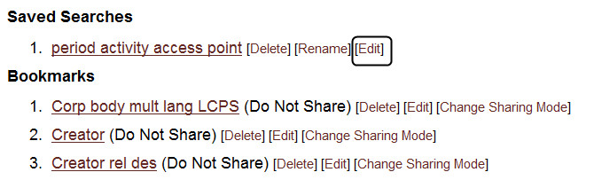

- 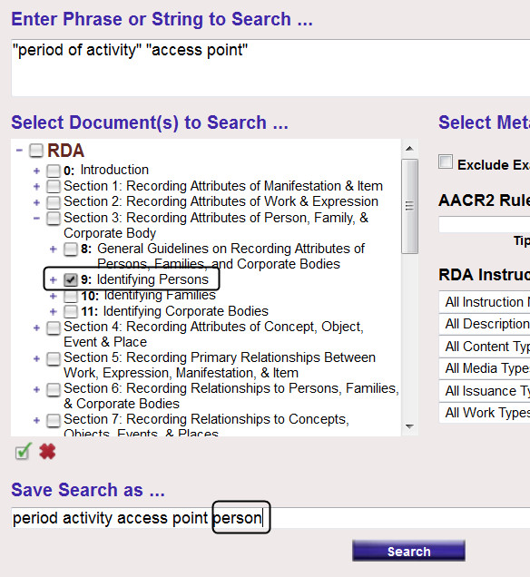Expand the RDA hierarchy and limit the scope to only Chapter 9 in section 3) of RDA
- At the end of the “Save Search as …” field, add person
- Click on Search

- Click on My Profile

Because we saved the search with a new name – just like saving a Word document with a new name – we now have 2 related saved searches.

- Note that we could simply rename a saved search, without changing the search strategy.

THIS PAGE INTENTIONALLY BLANK

Unit 5: User-Contributed Content
User-contributed content allows users to create, share, copy, and modify their own content in the RDA Toolkit. This content could take several forms:
- local workflows
- local policies
- mappings to encoding standards
- local training guides
- individually-created ‘job aids’

The Toolkit ‘comes with’ two categories of such content: workflows and mapping. In this course, we will look briefly at existing workflows and maps, but will not create our own.

Workflows
Catalogers sometimes create workflows for cataloging different types of items. Workflows are step-by-step instructions for performing an aspect of cataloging, whether a specific part of a record or a complete record. The RDA Toolkit Workflows are an online repository of these workflows for personal, institutional, and global reference. This can eliminate the need to leave the RDA Toolkit to reference local documentation and provide the ability to link from local documentation directly to RDA instructions.

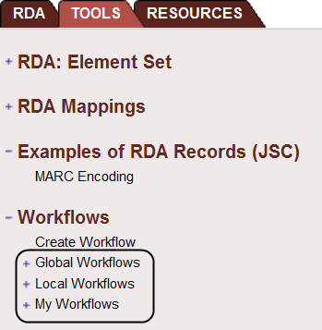You can include active links to RDA instructions and to other resources. You also specify if you wish to share the workflow with anyone using the Toolkit (“Global”) or only with others at your institution (“Local”). Workflows may be helpful to catalogers making the transition from AACR2 to RDA, or who need to catalog a type of resource they’ve not cataloged before, and to persons who have not cataloged at all. If you want to put any personal reminders or ‘job aid’ in the Toolkit, please ensure that the document is in the “My Workflows” list.

For grouping purposes, it is important to standardize how the shared workflows are named, by indicating the institution’s name at the beginning of the workflow name.

LC catalogers are welcome to utilize any Workflows -- even those not created by LC -- that you find useful. If you have interest in creating a workflow that you and your colleagues would like to see in the Toolkit, please contact the Policy and Standards Division so you can determine how to develop the workflow.
Suggested exercise to do on your own

- Click on the Tools Tab
- Expand the “Workflows” hierarchy, and then expand the “Global Workflows”
- Scroll down and click on LC Staff: Transcribing
This Workflow is a useful one-stop compilation of all the RDA instructions on transcription. This particular Workflow starts with a hyper-linked “table of contents”.
- Click on the jump-link to Language and Script
- Read the first paragraph and then follow the link to RDA 1.4
- Click on the Tools tab in the Browse Tree and then on the Workflow
- Click on Capitalization and follow the link to LCPS 1.7.1
- Click on the Tools Tab to return to the Workflow

To see a workflow that walks you through the process …
- In the Tools Browse Tree, click on the Global Workflow, LC Staff: Simple Book
- Browse through this workflow to see that it presents a step-by-step ‘tutorial’, complete with links to the relevant RDA instructions

- Click on the Global Workflow, RDA 199: Relationship Designators Workflow
- Scroll down and click on MARC21 Bibliographic Mappings for RDA 18.5
Note that this jumps you to the resource for mapping RDA to MARC, which is on the Tools tab
- Click on the Back button of the Browser Navigation Bar to return to the Workflow

Maps
Maps are tools created by Toolkit users to supplement the RDA Mappings authorized by the Joint Steering Committee, which we navigated briefly in Unit 2.

As with Workflows, LC catalogers should not create Maps without first consulting PSD.

Suggested exercise to do on your own

- 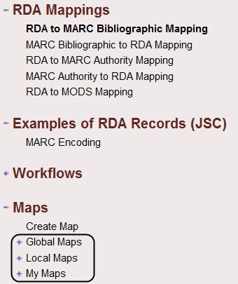Collapse the Workflows hierarchy
- Expand the “Maps” hierarchy and then expand the “Global Maps”
- Click on What is a Mapping? for a very general explanation of mappings
- Click on RDA to DC (Test) for a more useful mapping of some specific RDA instructions to the Dublin Core elements
- Click on Stanford MTS Scores for a more robust mapping of MARC data likely to be encountered in records for music scores, mapped to corresponding RDA instructions, with examples and notes

Unit 6: Help, Support, and Other Resources

Help with Toolkit Functionality

RDA Toolkit Help

Click on the Help link at the bottom of the Toolkit Browse Tree.

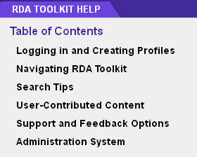A separate window opens with a Table of Contents of several Help topics. Most of these topics are covered in greater detail elsewhere in this document.

You can print a topic from the icon in the blue bar at the top. And because “Help” is a separate window, you can browse through it without losing your place in RDA or other resources.

Close the “Help” window

Support

Click on the Feedback link at the bottom of the Toolkit Browse Tree

The “Welcome to the Support Center” page opens. From this page, you can “Open A New Ticket” to send a free-form question to ALA., or you can check the status of existing ‘tickets.’

Toolkit Home Page

Click on the RDA Toolkit logo above the Browse Tree.

The Toolkit Home page opens in a separate browser tab

In the Navigation frame at the left, click on Blog

The Blog presents a variety of information, updated frequently, including the latest developments, interviews with Vendors, and ‘how-to’ advice. The Blog categories (at the right) group information on particular topics.

- Briefly scroll down the Blog Categories to see what categories exist

- You are encouraged to view the Blog regularly. If you wish to comment, you will need to create an account and login; this takes only a few minutes.
In the Navigation frame at the left, click on Development

Here you can read about the status of recent Toolkit developments and revisions. Particularly helpful are the brief descriptions of the bi-monthly Toolkit “Releases.”

As with the Blog, Categories at the right help to group the many development items.

In the Navigation frame at the left, click on Teaching and Training

Here you can access archived webinars and presentations on the Toolkit.

Click on Video Help
ALA has an on-going effort of creating a variety of short video guides.

Click on RDA Toolkit Essentials
These are webinars of live demonstrations of Toolkit features.

FAQ
Frequently Asked Questions are available by clicking on the link at the top-right of the interface.

Help Applying RDA Content

Examples
The Toolkit contains examples of RDA bibliographic and authority records.

- In the Navigation frame at the left, click on RDA Examples
- Click on Examples of MARC RDA Record (JSC)
- Click on Examples of MARC RDA Record (JSC) - bibliographic records to launch the examples in a new browser tab.

There are examples in a variety of formats (audio recording, book, serial, video recording, and web site). For each example, there is a table of RDA elements, ISBD punctuation and the RDA reference, and another table showing MARC coding. The bookmarks at the left help you navigate quickly through the examples.

- Click on the Back button in the browser

You could also click on the link for authority records to see examples for persons, families, corporate bodies, works, and expressions. As with the bibliographic examples, for each example, there is a table of RDA elements, ISBD punctuation and the RDA reference, and another table showing MARC coding.

- Close the “Help” browser tab
- Click on Logout to logout of both your Profile and the Toolkit in one step

Appendix: Quick Reminders about the RDA Toolkit
- Remember the two-stage authentication and login procedure. You must first be authenticated into a Toolkit account, using whichever authentication procedure is in use in your institution; you may then decide to go further and login to your personal profile.

- If you get timed-out, click on the large blue “Access RDA Toolkit” button; you will to again login.

- Generally, do not use the browser “Back” and “Forward” buttons for navigation within the Toolkit.

- Remember to clear your previous “Advanced” search.

- Always follow the directions of the LC-PCC PS, if that is appropriate for your institution.

- Do not ‘freeze’ yourself out of seeing important instructions by searching too narrowly or by using filters or instruction types injudiciously.

- On the other hand, with experience you can search more effectively by carefully selecting only portions of RDA or LC-PCC PS to be searched (e.g., a specific section or chapter)

- Be careful to know whether you are looking at RDA or LC-PCC PS.

We will use Firefox in class. You can also utilize the RDA Toolkit in Internet Explorer, version 8 and later. If using the Toolkit through IE, some features may look and function differently than presented in this material.

